Memories of David Frischknecht on His 60th Birthday
By Larry Richman, October 1, 2015
You wrote 60 memories of me for my 60th birthday, so now I’m returning the favor with 60 for your 60th.
- I remember meeting you for the first time in February 1975 when we were assigned as missionary companions in Patzicía, Guatemala. Dr. Robert Blair taught a dozen Elders for a few weeks, then we were on our own to learn from the people.
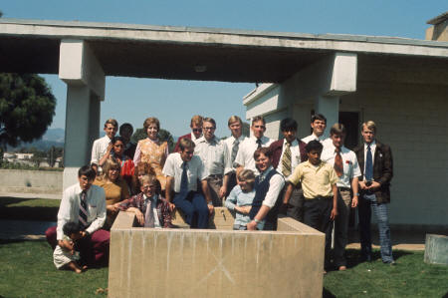
- I remember this picture of you, Dr. Robert Blair, and Spencer Palmer in front of Hortencia’s store in Patzicía where the missionaries rented a room.
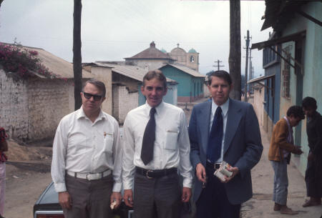
- We continued to study and teach in Cakchiquel daily. Toward the end of our missions, I remember times where you and I were deep in conversations about the people, we would slip into Cakchiquel because it felt more natural than English.
- I remember walking and walking up and down the streets of Patzicía for the nearly four months that we were companions (2-4-75 to 5-29-75). Those were great days. I don’t remember a time we didn’t get along.
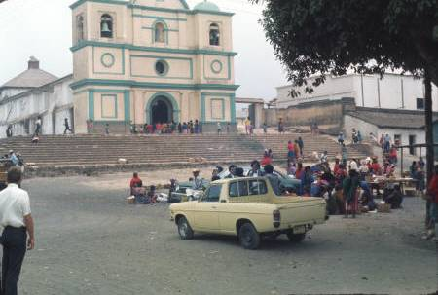
- We even scouted out vacant lots.
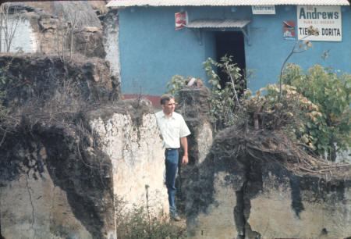

- And we walked some more
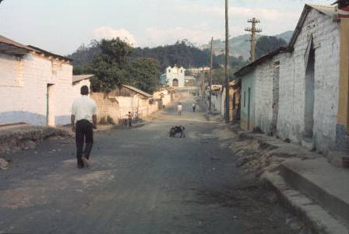
- Some of the people called you "Frishmar" (because they couldn't say "Frischknecht" and they confused "Frischknecht" and "Richman").
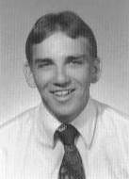

- I remember we vaccinated chickens in the marketplace in Patzicía, Guatemala on Wednesday, February 19, 1975.
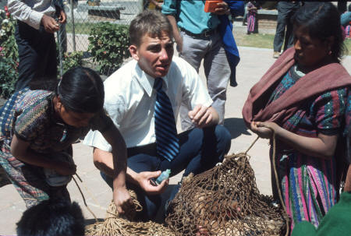
- I remember shopping at the market with you.
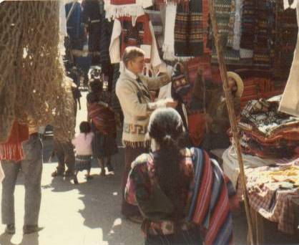
- I don’t think you bought this hat, but you should have.
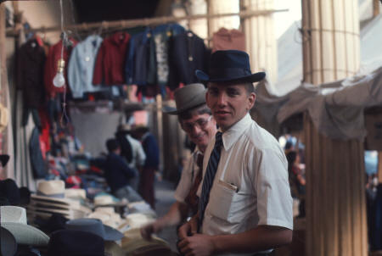
- We rented a room from Don Chomo and Doña Hortencia Ruiz. They had a store in the front of the house.
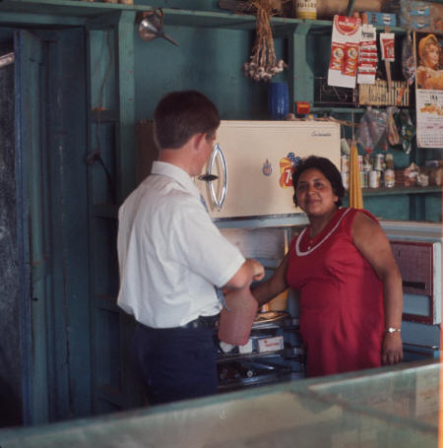

- And sometimes there were odd surprises in the fridge.
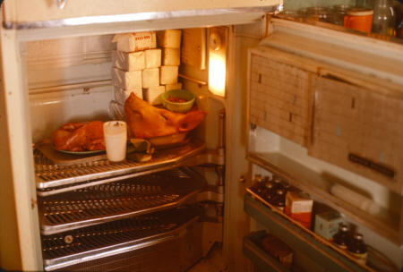
- Hortencia's maid was named Carmela. The blouse she is wearing cost 3 month's wages.
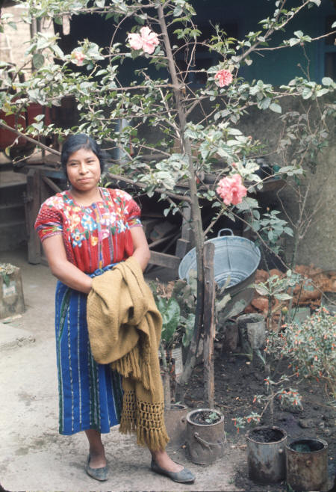
- Hortencia's mom was Rosario. In this picture, she is covered in flour from the bakery in the back of the house.
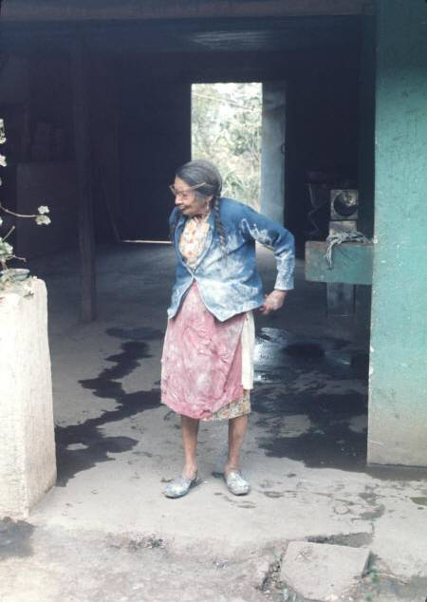
- This was the outhouse we used in Patzicía.
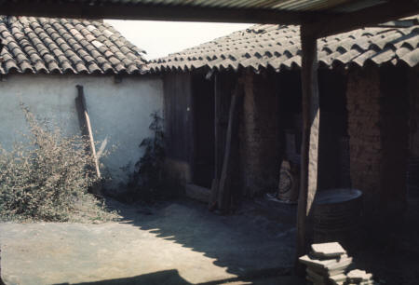
- We spent lots of hours studying the gospel and studying Cakchiquel. Some of us studied and some slept.
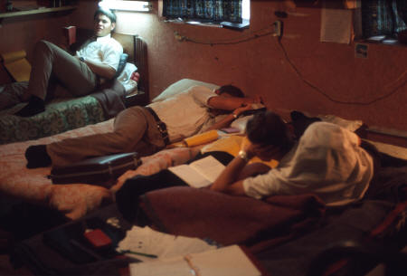
- I remember writing the famous letter to President Arnold. I read it aloud to you and the other missionaries and no one stopped me from mailing it. (You should have stopped me.)
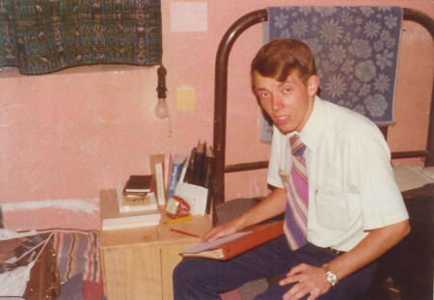

- This is the church in Patzicía where we grew to love the members.
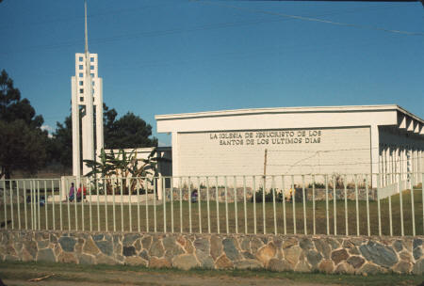
- Behind the Patzicía church was a small co-op with animals that the welfare system set up years before.
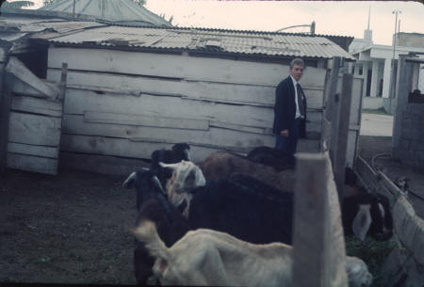

- We walked the streets of Patzicía to update an old map of the town. We made copies to help with missionary work and we presented a copy to the mayor.
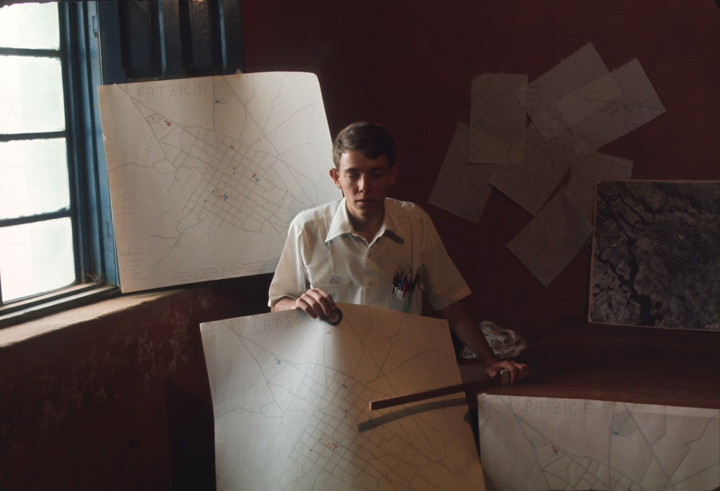
- We worked hard, but also enjoyed associating with all the missionaries.
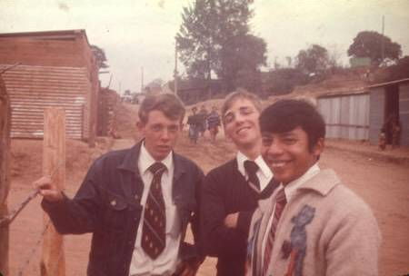

- Your favorite line was "Keep Smiling."
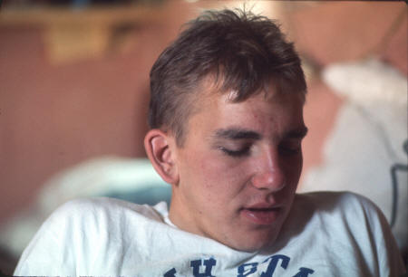
- You had a harmonica in Patzicía.
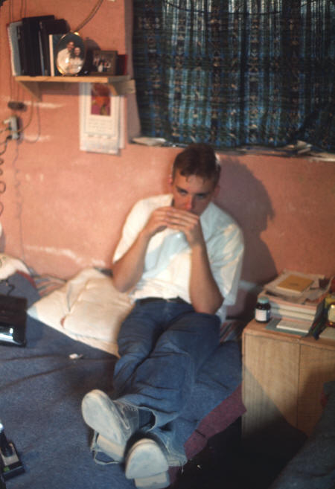
- And you even played it on the streets.
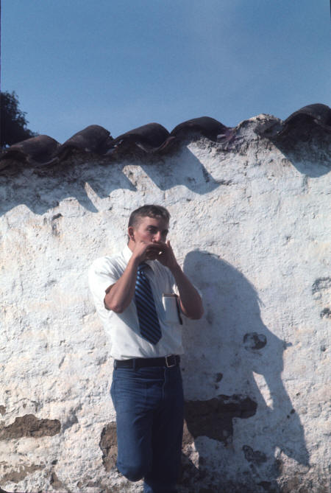

- You had a great coat.
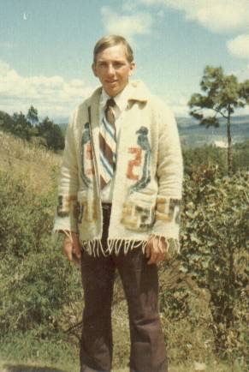

- And great pants.
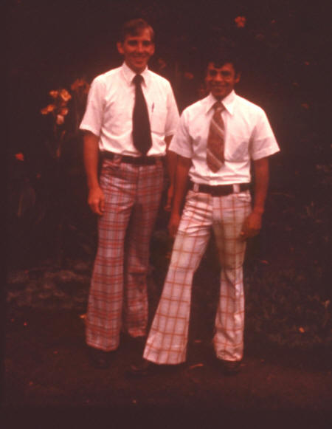

- But you weren’t as cool as I was.
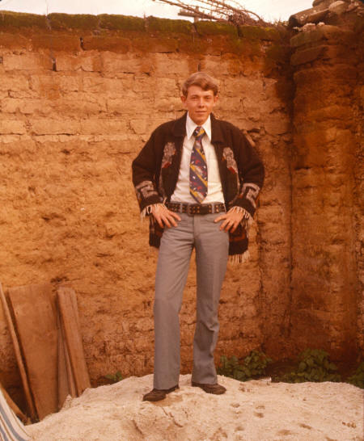

- You were a friend to all the kids. Here you are with Austin Choc and Cesar at the Calvario in Patzicía
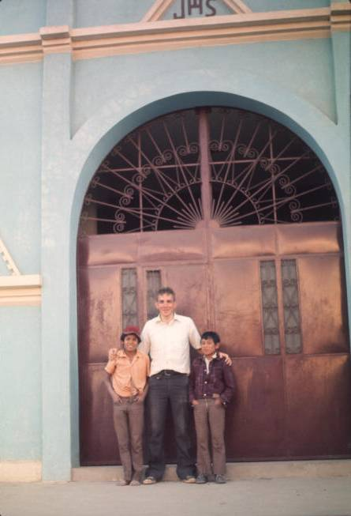

- And here you are with Magdelena, Florinda, and Rolando Choc.
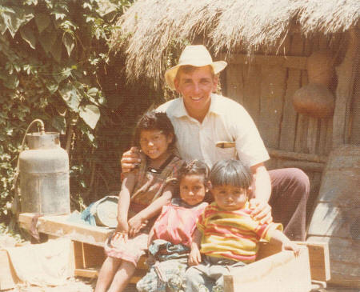
- Here’s you and Elder Warnock.
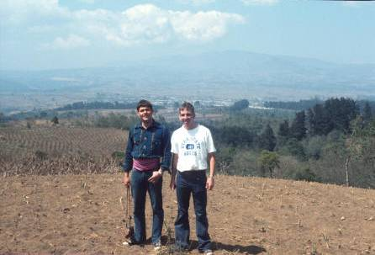

- I remember we hiked up the volcano Agua in 1974. Pictured are Elder Martin, you, and me in Antigua the night before the hike.
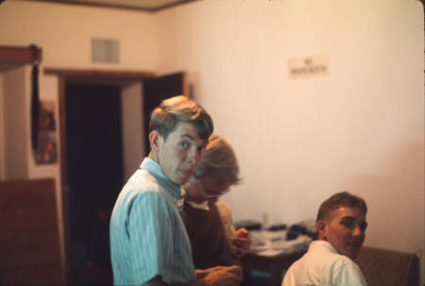
- We celebrated your birthday in 1975
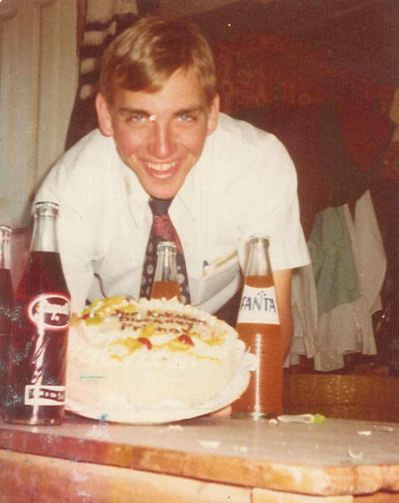
- And you remembered my birthday. (Not just that year, but every year since.)
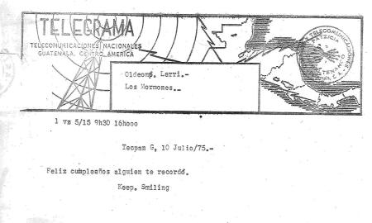
- And you remembered my “hump day” (one year mark).
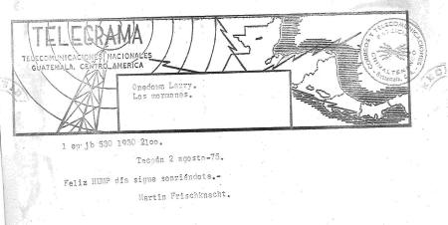

- We sent lots of telegrams, communicating with the other missionaries. We became good friends with the postmaster and telegrapher Jorge Blas.
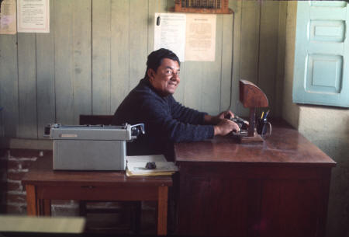
- We took trips to Lake Atitlán. Here you are with Elders Taz Evans and Greg Martin.
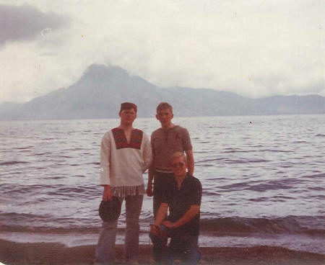

- We road lots of buses.
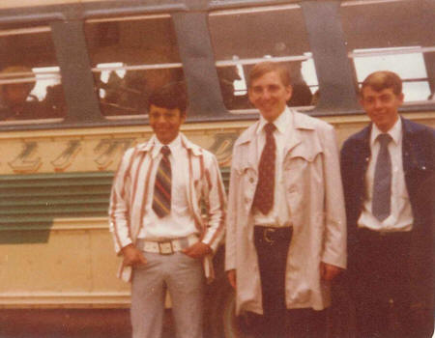

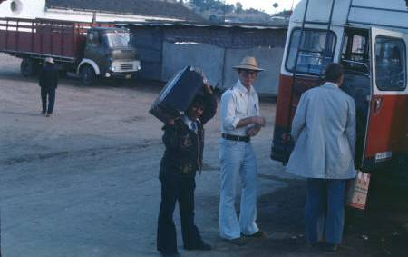

- I remember well the days in Comalapa: Elder Frischknecht, Elder Argueta, Elder Choc, and Elder Richman standing on the street in front of Walter Matzer's house where we rented two rooms.
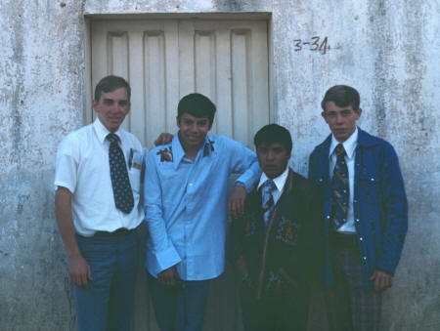
- Our house in Comalapa: Elder Frischknecht, Elder Argueta, Elder Choc, and Elder Richman
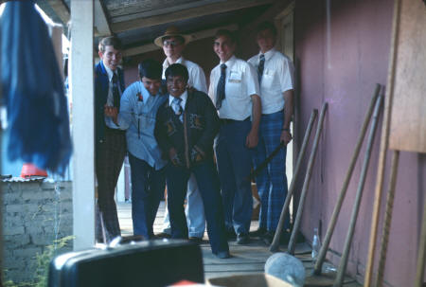
- We ate our meals at the comedor Don Juan. One morning when we arrived to eat breakfast, Don Juan wasn't there, so we asked the Indian lady who cooked the meals where he was. She shrugged her shoulders and said "Cuando yo venís, ella no está."
- You taught in a street exhibit at the Comalapa cemetery on the Día de los Santos, November 1, 1975
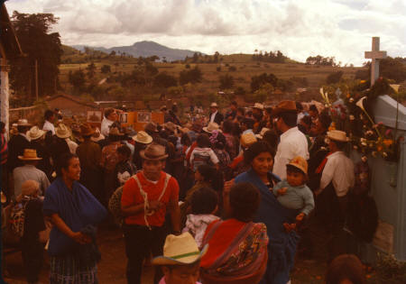
- We experienced the earthquake in 1976. You were with Elder Choc in Sumpango and I was with Eber Caranza (a member from Patzún) in Comalapa.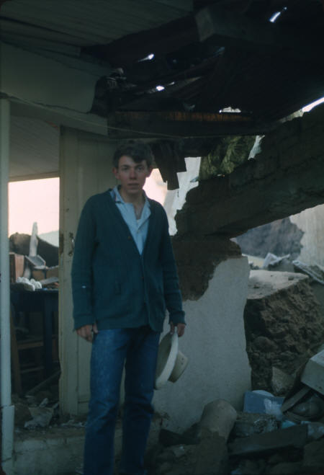
- The devastation was widespread. 23,000-25,000 people died, 80,000 were injured, 250,000 homes were destroyed, and nearly 1.5 million inhabitants were left without shelter.
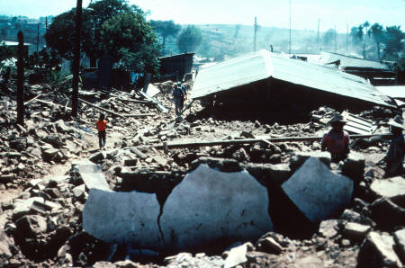
- The Patzicía church didn’t survive.
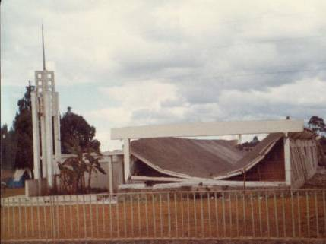

- And neither did 15 members in Patzicía.
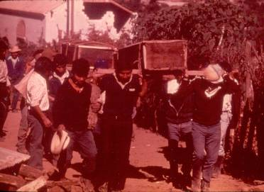
- We served together in Camp Patzicía in February and March of 1976. Pictured are Elders Richman, Salazar, Choc, Evans, Larson, Frischknecht, and Bernhardt.
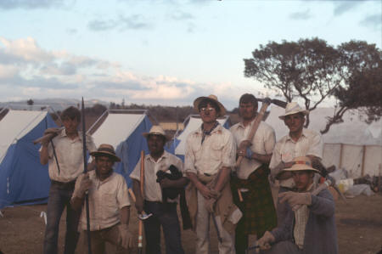

- We had great camp supervisors. Pictured: Bleak Powell, David Frischknecht, Garth Howard, Cleo Fromm, Kelly Robbins, and Hye Fromm.
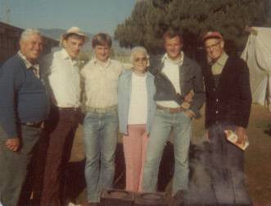
- You were a comfort to Pablo, Daniel, and Austin Choc, after they lost their wife/mother and 2 kids in the earthquake.
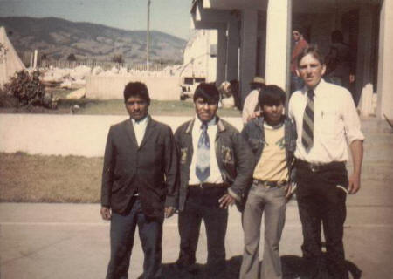

- And you were also a strength to Pablo when Daniel was killed on a work day in Patzún.
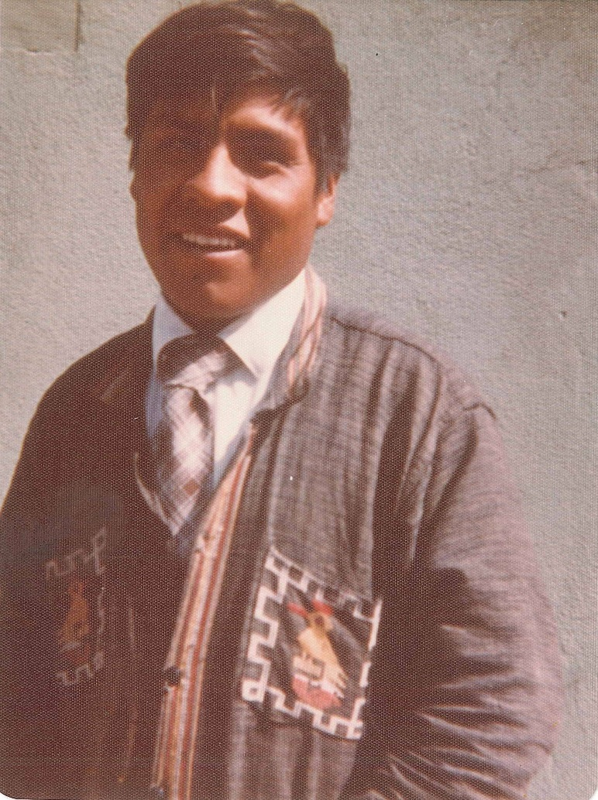

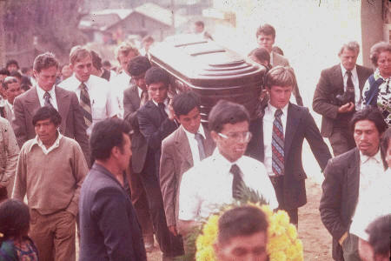

- We helped build an adobe house for Leocadio Per.
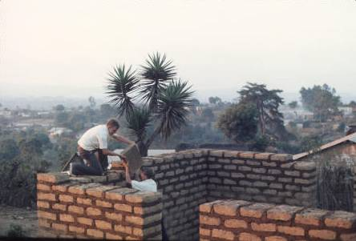
- We held some meetings in Itzapa.
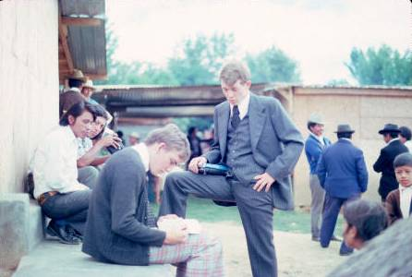

- The last month of my mission (July 7–August 3, 1976), we worked in a make-shift office in the Patzicía church to finalize the translation of the missionary discussions in Cakchiquel, along with Julio Salazar.
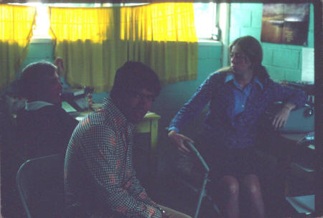
- You were there when my parents came to Guatemala at the end of my mission. Elder Larson, you, and I visited Daniel’s grave with my dad.
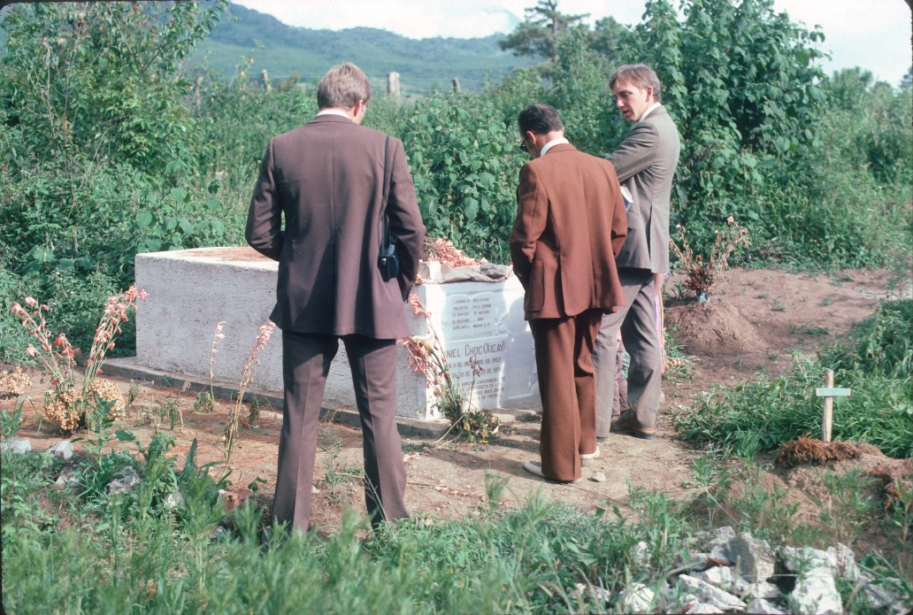

- We returned to Guatemala during the summer of 1977 to translate the Book of Mormon into Cakchiquel. You did the initial translation with Julio Teleguario in Patzún and I typed the translations and reviewed them with a group of Church members from Patzicía. We also translated some sections from the Doctrine and Covenants, and many hymns.
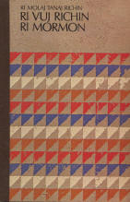
- We were roommates for years at BYU.
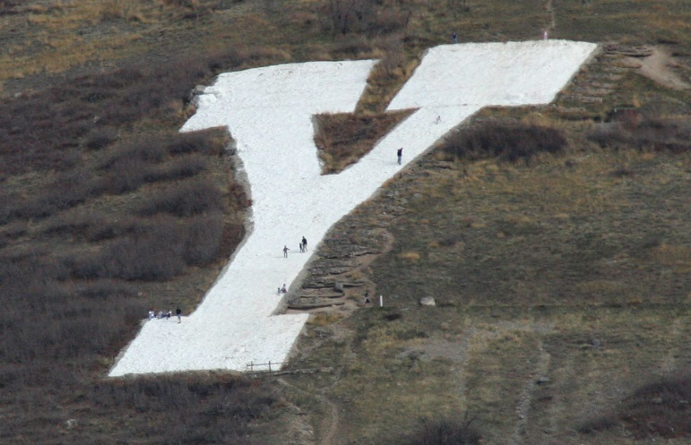

- We translated and recorded the temple ceremonies in Cakchiquel.
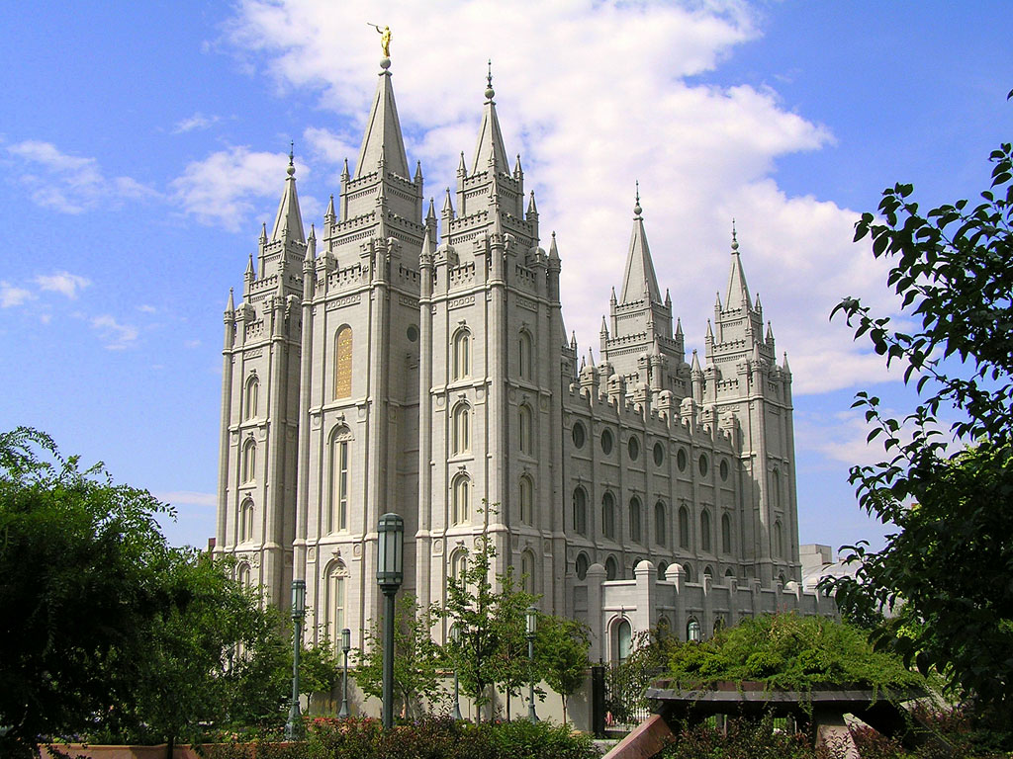
- We served together in an elder’s quorum and in a bishopric in singles wards at BYU.
- I helped line up you and Nancy for your first date. And look where that got you.
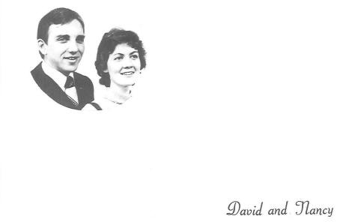

- I remember going to the temple with you and Nancy on July 18, 1979, to do the temple work for Ricardo Cua and his wife Arcadia Miculax

- After returning from our missions, we both decided to work for the Church and have made it our careers. We’ve worked together and in separate departments several times. You were my managing director in the Curriculum Department, but I never felt you were my “boss.” You always treated me as a friend and fellow co-worker.

And for these, and many more reasons, I’m grateful that you are my friend.

For more photos and memories, see larryrichman.org/mission

